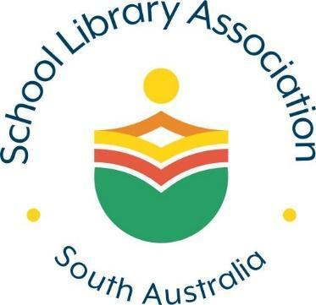 | Innovation in School Libraries  Awarded to individuals/teams that have introduced initiatives that promote outstanding library service and positive learning opportunities to their school community.  Proudly offered by The School Library Association of South Australia (SLASA)

Award Guidelines

- Initiatives may include activities or programmes facilitated by or run in partnership with the school library that promote positive outcomes for the school’s community.

- This form, with attachments, is to reach The Secretary - SLASA, at slasa@slasa.asn.au by 15 December 2022.

Nomination Details

This nomination, with attachments, has been forwarded by:

Full name of nominator(s)
School address of nominator
Phone number of nominator
Nominator’s email address
Brief description of the project

Attachments:

[ ] An overview of the innovation that includes the project background, implementation details and the impact on the school community.

[ ] Supporting evidence of the impact on the school community.

Signed: __________________________________Date: ________________________

