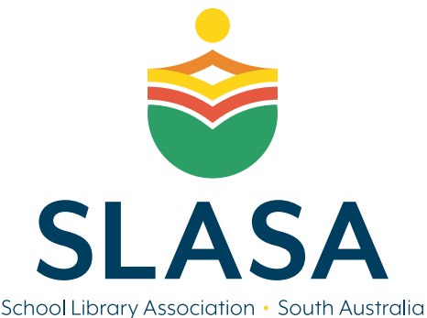
Innovation in School Libraries
The Award
Innovation in School Libraries is awarded to individuals/teams that have introduced initiatives that promote outstanding library service and positive learning opportunities to their school community.

Initiatives may include activities or programmes facilitated by or run in partnership with the school library that promote positive outcomes for the school’s community.

The Award will be announced and presented at the SLASA AGM in Term 1 2024.
Proudly offered by The School Library Association of South Australia (SLASA).
Nominations
The completed nomination must be submitted on time and include:
- an overview of the innovation that includes the project background, implementation details and the impact on the school community.
- any additional supporting evidence (photos, letters from parents or school staff, social media posts etc)
Submit nominations via email to slasa@slasa.asn.au ~ Subject: IiSL Award ~ by 21 FEBRURAY 2024

Nominee Details ~ SLASA Innovation in School Libraries Award
Name of Nominee/School | Click or tap here to enter text.
School Address | Click or tap here to enter text.
Email address | Click or tap here to enter text.
Contact phone number/s | Click or tap here to enter text.

Brief description of the project: further details to be included as supporting evidence.
Click or tap here to enter text.

Nominator Details (If different to above)
Full name | Click or tap here to enter text.
School Address | Click or tap here to enter text.
Phone number | Click or tap here to enter text.
Email address | Click or tap here to enter text.

I hereby declare that, to the best of my knowledge, the information supplied on and with this form is correct in every detail.

Signed: __________________________________Date: __ Click or tap here to enter text. ___

