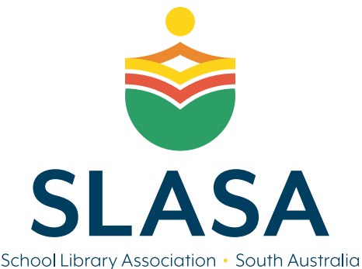
The Joan Brewer Teacher Librarian Award
for outstanding service to teacher librarianship and/or school libraries in SA

Mrs Joan Brewer AM, FACE
Mrs Joan Brewer was born in Adelaide and completed her initial teacher training at Adelaide Teachers College and The University of Adelaide.
After teaching at Naracoorte HS, she became a Librarian, firstly with the Barr Smith Library at The University of Adelaide, and later in London. In 1957 Joan returned to Adelaide and to the newly established Wattle Park Teachers College, as Lecturer Librarian.
In 1964, with her dual qualifications, Joan was invited to, and accepted the challenge of establishing the first full time course for Teachers to become Teacher Librarians at the newly opened Western Teachers College. 1970 saw Joan appointed as Senior Lecturer Librarian of the Department of School Librarianship at Adelaide C.A.E. Joan, a strong advocate for Teacher Librarians, retired from her position as Principal Lecturer in 1984 and was awarded her AM in January 1985.
Joan was the inaugural patron of SLASA, and this award is named in her honour.
The Award will be announced and presented at the SLASA AGM in Term 1 2024.
Proudly offered by The School Library Association of South Australia (SLASA).
The Award
The Joan Brewer Teacher Librarian Award is awarded to a person giving outstanding service to Teacher Librarianship and/or school libraries in South Australia.
Nominations
The completed nomination must be submitted on time and include:
- a full curriculum vitae, including details of nominee’s contributions to Teacher Librarianship and/or school libraries in South Australia
- any additional supporting evidence (Professional learning certificates, testimonials, photos, social media posts etc)
Submit nominations via email to slasa@slasa.asn.au ~ Subject: JBTL Award ~ by 21 FEBRURAY 2024

Nominator Details
Full name | Click or tap here to enter text.
Address | Click or tap here to enter text.
Phone number | Click or tap here to enter text.
Email address | Click or tap here to enter text.

Nominee Details ~ SLASA The Joan Brewer Teacher Librarian Award
Name of Nominee | Click or tap here to enter text.
Current Position | Click or tap here to enter text.
Principal/Employer’s Name | Click or tap here to enter text.
School Address | Click or tap here to enter text.
Email address | Click or tap here to enter text.
Contact phone number/s | Click or tap here to enter text.

Professional Qualifications: Please list any relevant qualifications. These should be included as supporting evidence.
Click or tap here to enter text.

Areas of outstanding service to Teacher Librarianship and/or school libraries in SA:.
Click or tap here to enter text.

Actions initiated/undertaken for the benefit of the profession:
Click or tap here to enter text.

Reasons for nomination: Please limit to 500 words.
Click or tap here to enter text.

Other supportive information: Please include any testimonials (limit to 300 words ea) as attachments to entry.
Click or tap here to enter text.

The candidate described above has my official support.

I hereby declare that, to the best of my knowledge, the information supplied on and with this form is correct in every detail.

Signed: __________________________________Date: __ Click or tap here to enter text. ___

