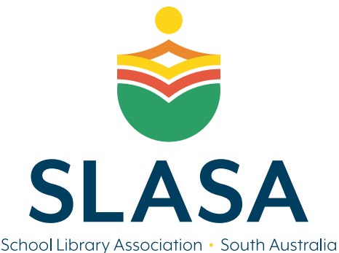
Library Advocate Award
The Award
This award is to encourage library staff to further develop their professional learning and recognise the positive contribution they have made to their school community. This award is open to any library staff working in a school library. The nominee will need to be able to demonstrate engagement with their school community, wider networks, online forums, and attendance or engagement with professional learning
The Recipient/s of the Award will receive:
- 12-month SLASA individual membership (to promote ongoing professional learning)
- Free access to SLASA Professional Learning for the Year.
The Award will be announced and presented at the SLASA AGM each year.
Nominations
Principals, professional colleagues, and members of the school community are encouraged to nominate their library staff members for this award. The nominee is not required to be a member of SLASA. The nominee must reside in South Australia and be working in a school library.
The completed nomination must be submitted on time and include:
- Letter of service from your current school demonstrating library experience
- Two testimonials from your school or a colleague
- Any other additional supporting evidence (e.g. photos, testimonials, social media, community news reports, podcasts, engagement with school community etc.)
Submit nominations via email to slasa@slasa.asn.au ~ Subject: LA Award ~ by 21 FEBRURAY 2024
The award will be presented at the School Library Association of SA, AGM in Term 1 2024.

Nominee Details ~ Library Advocate
Name of Nominee | Click or tap here to enter text.
Current Position | Click or tap here to enter text.
Principal/Employer’s Name | Click or tap here to enter text.
School Address | Click or tap here to enter text.
Email address | Click or tap here to enter text.
Contact phone number/s | Click or tap here to enter text.

Professional Qualifications: Please list any relevant qualifications. These should be included as supporting evidence.
Click or tap here to enter text.

Statement of achievements: Please address how you have advocated for your library within your school community, wider networks, online forums, and engagement with professional learning. Responses should not exceed 500 words.
Click or tap here to enter text.

Two written testimonials provided by professional colleagues: These should support the application and endorse some of your achievements. Please limit testimonials to 300 words. At least one of these should be your School Principal.

Please include as attachments

1. Name: Click or tap here to enter text.
Position: Click or tap here to enter text.
Contact: Click or tap here to enter text.

2. Name: Click or tap here to enter text.
Position: Click or tap here to enter text.
Contact: Click or tap here to enter text.

I hereby declare that, to the best of my knowledge, the information supplied on and with this form is correct in every detail.

Signed: __________________________________Date: __ Click or tap here to enter text. ___

