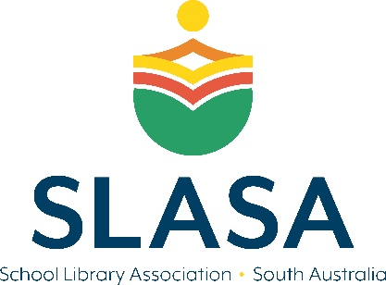 | SLASA  Bookmark Competition for School Students

Who can enter?
The competition is open to all school aged students in SA.

What do I need to do?
Working individually, students create a bookmark with the theme “Everything is possible in my school library”. Students can use any media, including but not limited to paint, pencil, pastels, digital and photography.

When is it due?
All entries accepted will be received by Friday 11th of November 2022. The winners will be announced Friday 18th of November 2022 via social media and on the SLASA website. Winners will be contacted shortly after to arrange for prize delivery.

Is there an entry fee?
Entry is free.

What are the Prizes?
10 students have the opportunity to win a $25 book voucher from the book store of their choice.

How should I submit my entry?
Entries and forms can be submitted together via email to slasa@slasa.asn.au
All entries are to be submitted via email in JPEG format and clearly labelled so the correct entry forms can be assigned to the correct art work.

Terms and Conditions
1. All entries will remain the property of SLASA.

2. The closing date is Friday 11th of November 2022. Entries will not be accepted after this date.

3. Winners will be notified by email/phone.

4. Winners’ names will appear in our first SLASA newsletter after the announcement as well as on our website and social media

5. Entries may be displayed at selected SLASA events, website, Facebook page or newsletter. Entries may be used as SLASA publicity material.

6. The Judges’ decision is final and no correspondence will be entered into.
SLASA

Bookmark Competition for School Students

Entry Form

Entries are due by Friday 11th of November 2022.

School:______________________________________________________________________________

Telephone:______________________________________

Email contact:________________________________________________________________________

Student Name:______________________________________________________________________

School year level and class name:________________________________________________________

- I agree with the terms and conditions of the competition.
- I confirm that the work has been made personally by the student and has not been published.
- I understand that entries may be displayed at selected SLASA events, website, Facebook page or newsletter. Entries may be used as SLASA publicity material.

Parent / Guardian name and signature: ___________________________________________________

Please ensure that this completed entry form is attached to each artwork.

